**Robotics and Coding for Kids I:** Kickin’ It with STEAM

In this four week STEAM class, Brick Scholars construct LEGO® WeDo™ robots, and program them to move, make sounds, and add special effects. The students will construct three builds: Goal Keeper, Cheerful Fans, and Goal Kicker. This unit focuses on Mathematics. The students will measure distance, calculate the number blocks, goals, and misses. They will also learn to program an automatic score keeping system.

* Homeschool Class: 1:00 – 2:30 pm

May 5, 12, 19, 26

* Saturday Half Day Camp: 12:30 – 3:30 pm May 7 & 28

**Why Brick Scholars?**

**What makes this class different than a retail LEGO® set my kid can do at home?**

Brick Scholars classes are educational and designed using *Best Practices* teaching and learning methods. Each class uses a standards-based STEAM curriculum and integrates research-based and brain-based educational theory, including LEGO® Education pedagogy, Constructivism Educational Theory and Theory of Learning (Seymour Papert, Jean Piaget, and Lev Vygotsky).

**STEAM** is an acronym for **S**cience **T**echnology **E**ngineering **A**rts **M**ath. This cross-curricular model engages the whole brain in a hands-on, minds-on approach to learning and offers engagement, critical thinking, and high order thinking skills. We use Marzano’s strategies and Bloom’s Taxonomy in our lesson plan design.

**Coding is the future!**

Some of the **STEAM standards** we meet in this class (based on **Next Generation Science Standards**) are:

**Engineering Design** (asking questions and defining problems, planning and carrying out investigations, constructing explanations and designing solutions)

**Disciplinary Core Ideas** (defining and delimiting engineering problems, developing possible solutions, optimizing the design solution) and

**Crosscutting Concepts** (influence of science, engineering, and technology on society and the natural world).

**Robotics and Coding for Kids I:** Mechanical Minds

In this four week STEAM class, Brick Scholars construct LEGO® WeDo™ robots, and program them to move, make sounds, and add special effects. This unit focuses on Physical Science concepts. Students will construct three builds: Smart Spinner, Dancing Birds, and Drumming Monkey. Students will experiment with the size of pulleys, crossing and uncrossing of belts, and the size of gears, levers, and patterns of movement.

* Homeschool Class: 1:00 – 2:30 pm

March 3, 10, 17, 24

* Saturday Half Day Camp: 12:30 – 3:30 pm March 12 & 26

**Robotics and Coding for Kids I:**

Into the Wild

In this four week STEAM class, Brick Scholars construct LEGO® WeDo™ robots, and program them to move, make sounds, and add special effects. Students will construct three builds: Roaring Lion, Flying Bird, and Hungry Alligator. The focus of this class is on the concept of sensing and responding to external stimuli. Students will learn to program each build. For example, in Hungry Alligator, the alligator will have to be programmed to snap its jaw when its motion sensor detects anything near the mouth.

* Homeschool Class: 1:00 – 2:30 pm

April 7, 14, 21, 28

* Saturday Half Day Camp: 12:30 – 3:30 pm April 16 & 30

**“Creativity is intelligence having fun.” – Albert Einstein**

**Pricing**

Homeschool Units:

Mechanical Minds 4 class unit $100.00

Into the Wild4 class unit $100.00

Kickin’ It with STEAM4 class unit $100.00

Saturday Half Day Camps:

Mechanical Minds 2 day camp $100.00

Into the Wild2 day camp $100.00

Kickin’ It with STEAM2 day camp $100.00

**LOCATION**

Education Exchange 3042 Forest Hills Rd SW,

Wilson, NC 27893

**Sign up today!**

[**www.BrickScholars.Weebly.C**](http://www.BrickScholars.Weebly.C)**om**

[**TheBrickScholars@GMAIL.COM**](mailto:TheBrickScholars@GMAIL.COM)

**(252) 230 6865**

Don’t forget to ask about our early bird registration and sibling discounts

**“We especially need imagination in science. It is not all mathematics, nor all logic, but it is somewhat beauty and poetry.” - Maria Montessori**

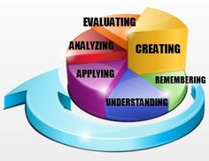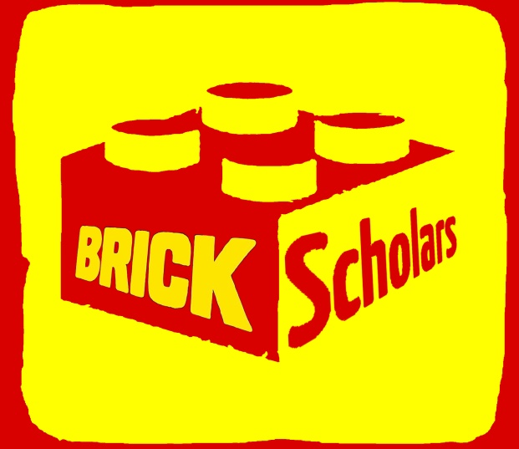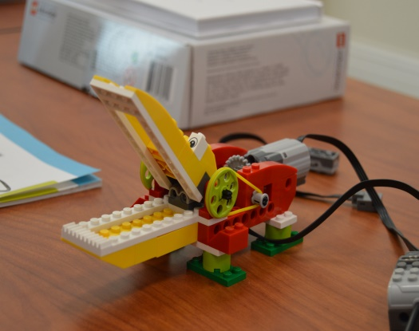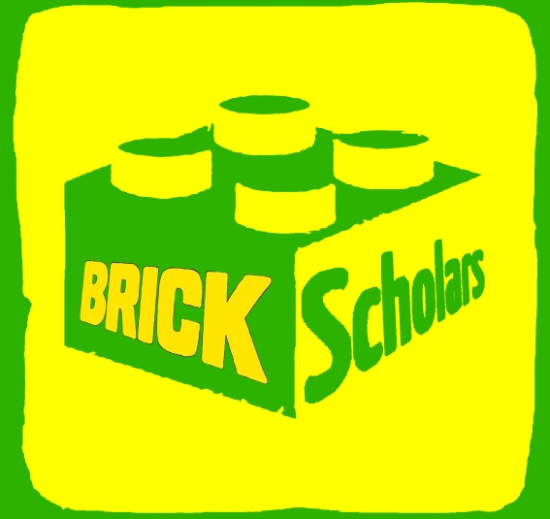

Brick Scholars provides educational classes, workshops, residencies, and summer camps for kids to brick and learn creatively with STEAM

* **S**cience
* **T**echnology
* **Engineering**
* **A**rts
* **M**ath

Megan Oteri, Brick Scholars’ Educational Director, is a certified North Carolina educator in Special Education (K-12); Elementary Education (K-6); and Language Arts (6-12). She has a bachelor’s degree in Elementary and Special Education from Providence College and a master’s degree in English with a concentration in Creative Writing from East Carolina University.

[meganoterieducator.weebly.com](http://www.meganoterieducator.weebly.com)

**Curriculum & Standards**

This class meets the following standards:

* Physical Science
* Simple Machines
* Common Core
* Next Generation Science
* National Core Arts

**Bloom’s Taxonomy**

Our classes meet the highest levels of Bloom’s Taxonomy.

[**www.BrickScholars.Weebly.C**](http://www.BrickScholars.Weebly.C)**om**

[**TheBrickScholars@GMAIL.COM**](mailto:TheBrickScholars@GMAIL.COM)

**(252) 230 6865**

**A SPECTACULAR way to bring STEAM to your kids!**

*Robotics and Coding*

*For Kids 1*

* **Early elementary STEAM learning with LEGO® Education WeDo**™
* **Physical Science and Simple Machines curriculum**
* **Intuitive, icon-based programming**
* **Integrated, cross-curricular activities that are engaging.**
* **Outstanding tools for building 21st-century skills.**

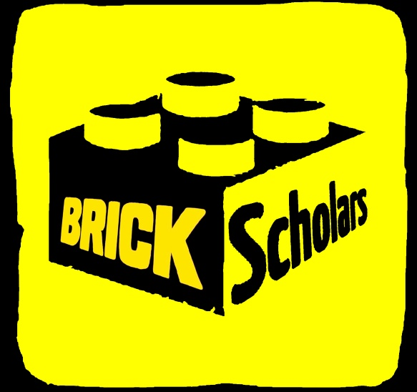

[**www.BrickScholars.Weebly.C**](http://www.BrickScholars.Weebly.C)**om**

[**TheBrickScholars@GMAIL.COM**](mailto:TheBrickScholars@GMAIL.COM)

**(252) 230 6865**